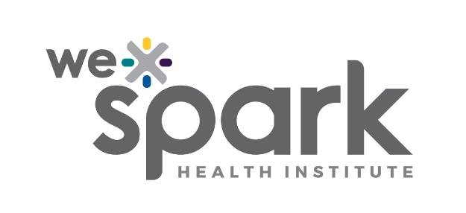
Program Name: Special Call: Student Research Training Grant
Funded by: University of Windsor Students‘ Alliance (UWSA) & St. Clair College Student Representative Council (SRC)

Program Launch Date: February 27, 2026

2026 Application

Due Friday May 8th, 2026 by 5PM
Submit Full Application online through Airtable here: WE-SPARK Student Research Training Grant 2026 Full Application
Convert this word document to a PDF prior to submission.

Principal Applicant

Surname, Given name: |  | Institution:
Faculty/ Department: |  | Email:

Project Information
Project Title:

Training Experience Overview (Maximum 1 page)

Describe the proposed research training experience, including:
- The research environment the student will be embedded in (lab, institute, clinical, community, innovation, or industry setting).
- The novel methodologies, technologies, or skills the student will be exposed to.
- The gap in the student’s current training and why this opportunity is transformative.
- How the experience will support new collaborations, inter-institutional partnerships, or expanded research networks.
- Why this training environment is uniquely suited to the student’s development.

Implementation Plan (Maximum 1 page)

Provide a detailed plan describing:
- Training activities the student will complete (methods, mini-project, collaborative work, etc.).
- Timeline (must occur between September 1, 2026 – August 21, 2027).
- Host environment details, including key personnel, facilities, or technologies the student will access.
- Travel, accommodations, or logistical arrangements, if applicable.
- Partnerships or collaborations supporting the placement.
- Risks or challenges (e.g., travel delays, access limitations) and mitigation strategies.
- Evaluation plan: How you will assess the student’s learning, skill development, and overall impact of the training experience.

Impact (Maximum 0.5 page)

Describe:
- How the student will benefit academically, professionally, and personally.
- How the project strengthens research capacity, collaboration, and/or partnerships.
- Broader impacts on the research program, community, or health system (if applicable).
- How the experience aligns with WE-SPARK's mission to support high-impact, collaborative research.

Budget

Briefly describe your budget and major use of funds. Funding must align with allowable expenses.

Direct costs of research | Total
Student stipend
Travel (e.g., transportation, mileage, airfare)
Accommodations
Training/course fees
Research-related materials
Administrative costs (insurance, visas, etc)
Other (e.g., dissemination, local transportation)
Total Request (Max $7,500)

Team (Maximum 1 page)

In one page, describe the project team.

Principal Applicant (Supervisor)
- Full name
- Role and responsibilities
- Relevant expertise, experience, and facilities
- How they will support the student’s training

Student Trainee (If a specific student has not yet been identified, describe the expected academic background and program level of the ideal trainee.)

- Background and academic program
- Research skills and training needs
- Rationale for selecting this student for the experience (if a candidate is identified)

Host Mentor(s) or Collaborators (if applicable)
- Name, role, and affiliation
- Expertise and relevance to the training experience

CVs

Attach a CIHR styled Biosketch CV along with this application for the Principal Applicant (Supervisor). CVs for students, co-applicants, or collaborators are not required.

Supplementary Pages (Optional – maximum 2 pages)

You may include up to two (2) supplementary pages at the end of this application. These pages may include, but are not limited to, figures, tables, training schedules, letters of support from host environments, and descriptions of specialized equipment or technologies relevant to the proposed research training experience. Formatting requirements do not apply. Include the supplementary pages at the end of the application.

