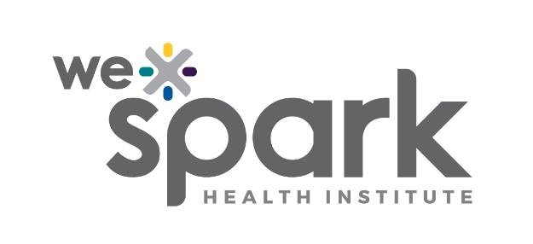
Funding Organization: WE-SPARK Health Institute

Program Names: Igniting Discovery Grants

Program Launch Date: February 27, 2026

2026 Letter of Intent (LOI)

Due Friday April 3, 2026 by 5PM
Competitiveness at the LOI stage refers solely to meeting eligibility and primary affiliation requirements; assessment of scientific merit occurs only at the full application stage. All applicants will be notified of the outcome of their LOI by April 10, 2026.

Submit LOI online through Airtable here: WE-SPARK 2026 Letter of Intent

Principal Applicant

Surname, Given name: |  | Institution:
Faculty/ Department: |  | Email:

Project Information (MANDATORY)
Title:

Project Summary (0.5 pages; MANDATORY)

Please provide a summary of your proposal here. Aim to include project rationale, research goals/ objectives, research approach/ methodology, team expertise, and potential outcomes.

