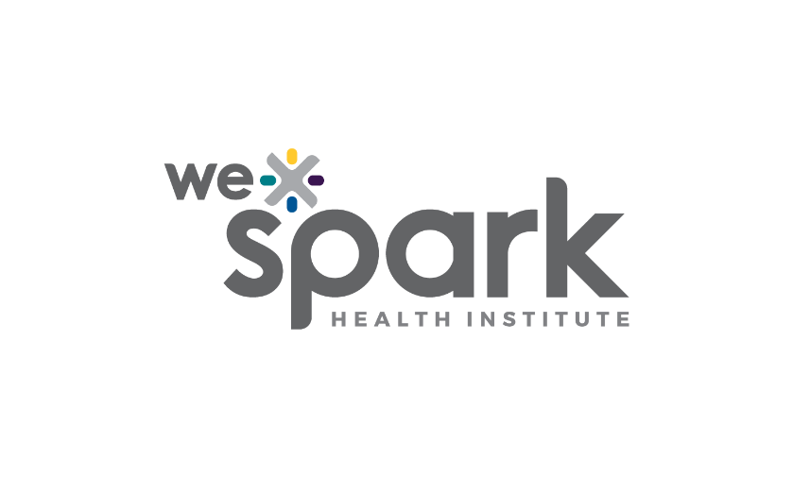
Funding Organization: WE-SPARK Health Institute

Program Names: Igniting Discovery Grants

Program Launch Date: February 28, 2025

2025 Letter of Intent (LOI)

Due Friday April 4, 2025 by 5PM
LOIs are non-competitive, it is strictly to assign reviewers. If you submit an LOI, you are eligible to submit a full application.

Submit LOI online through Airtable here: WE-SPARK 2025 Letter of Intent

Principal Applicant

Surname, Given name: |  | Institution:
Faculty/ Department: |  | Email:

Project Information (MANDATORY)
Title:

Project Summary (0.5 pages; MANDATORY)

Please provide a summary of your proposal here. Aim to include project rationale, research goals/ objectives, research approach/ methodology, team expertise, and potential outcomes.

