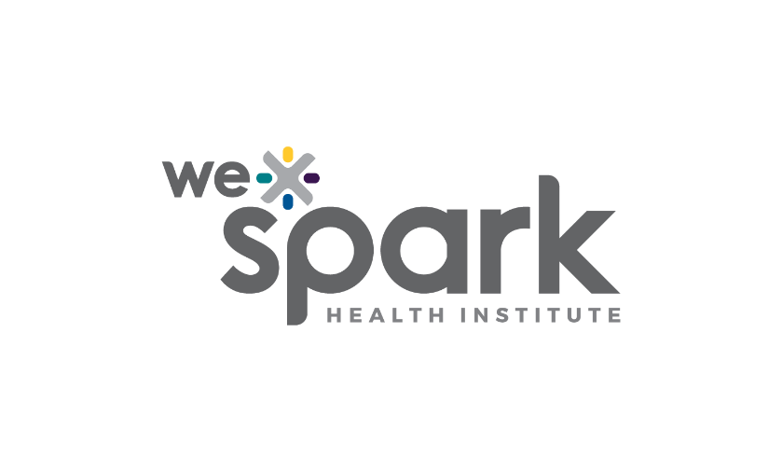
Funding Organization: WE-SPARK Health Institute

Program Name: Igniting Discovery Grants

Program Launch Date: February 28, 2025

2025 Application

Due Monday May 5th, 2025 by 5PM
Submit Full Application online through Airtable here: WE-SPARK 2025 Full Application
Convert this word document to a PDF prior to submission.

Principal Applicant

Surname, Given name: |  | Institution:
Faculty/ Department: |  | Email:

Project Information
- Title:

- Certifications required: Certification is a prerequisite for access to funds.
Research Ethics Board (project involves humans, tissues, cells, and/or fluids)
Animal Care
Biosafety (project involves biological agents, radioactive materials, lasers and/or X-rays)

Proposed Expenditures

- Funds Requested (maximum budget is $20,000 unless you are applying to the following priority research areas: 1) Cancer Research (maximum budget is $30,000); 2) Hematopoietic Stem Cell Research (maximum budget is $15,000); OR 3) Childhood Cancer Research (maximum budget is $25,000):

Direct costs of research | Total
Salaries (e.g., short-term positions)
Materials and supplies
Equipment or facilities (up to $2,000)
Other (e.g., participant incentives, gifts for Indigenous Elders):
Knowledge translation costs
Publications
Other:
Total Request

- Funds from Other Sources (if any): Please identify the amount of any cash contributions from other sources and differentiate how these will be used compared to the funds requested in this proposal.

1. Budget Justification (Maximum 1 page)

Justify the expenditures requested in the Proposed Expenditures table of this application form. Use the categories from the budget table as the headings in your one-page justification. Budgets will be evaluated based on feasibility.

2. Research Proposal (Maximum 4 pages)

A four-page research proposal that includes the following components:
- Rationale.
- Overall goal, and research aims/ objectives.
- Background. Preliminary data not required for this seed-grant application.
- Research approaches. Description should include timelines for the work to be done.
- Outcomes.

You may include a list of references (not part of the 4 pages) cited within the research proposal. Any standard reference style can be used, as long as it is consistent.

3. Team (Maximum 1 page)

In one page, describe the overall project team. Provide the following details for each team member:
- Full name
- Role (i.e., principal applicant, co-applicant, or collaborator)
- Professional affiliation most relevant to proposed project
- Responsibilities in project
- Expertise, experience, personnel, and/or facilities that makes the team member a perfect fit for their responsibilities.

4. Sex and Gender Considerations (Maximum 0.5 pages)

In half a page, please describe how sex and/or gender considerations will be integrated into your research proposal or explain why sex and/or gender are not applicable to your research proposal. You can review the “How to integrate sex and gender in research” section on the CIHR website for more information.
Did you complete one of the sex- and gender-based analysis training modules? (Y/N)

5. Equity, Diversity and Inclusion Plan (Maximum 0.5 page)

In half a page, describe both challenges in your research and training environment and the specific actions that you currently implement or plan to implement in your research and training approach. You may describe how you will recruit a diverse group of trainees and provide an inclusive research project/ research training environment.

6. CVs

Attach a CIHR styled Biosketch CV along with this application for the Principal Applicant as well as all Co-Applicants. Collaborators are not required to submit CVs.

7. Supplementary Pages (Optional – maximum 2 pages)

You may include up to two (2) supplementary pages at the end of this application. These pages may include, but are not limited to, figures, tables, and/or instruments relevant to the research project. Formatting requirements do not apply. Include the supplementary pages at the end of the application.

